Case Study On Kaziranga National Park

Submitted by: Yuvraj Vinayak Suryawanshi
Class/Roll No.: 181
Subject: Environmental Studies
Academic Year: 2026-2027

Index
Sr. No. | Topic | Page No.
1 | Introduction | 1
2 | Location and Geographical Features | 1
3 | Biodiversity and Species Richness | 2
4 | Major Flora and Fauna | 3
5 | Importance of Kaziranga | 4
6 | Major Threats | 5
7 | Conservation Efforts | 6
8 | Role of Local Communities and Tourism | 7
9 | Conclusion | 7
10 | References | 8

1.Introduction
Kaziranga National Park is one of India’s most significant wildlife conservation areas and is situated in Assam in northeastern India. It is globally recognised for its rich biodiversity, especially its large population of the Indian one-horned rhinoceros.
The park was declared a UNESCO World Heritage Site in 1985 and was later designated as a Tiger Reserve in 2007.
Kaziranga is an excellent example of successful wildlife protection and habitat conservation. Its grasslands, wetlands, forests and riverine ecosystems provide suitable habitats for numerous plants, mammals, birds, reptiles and aquatic species. The park lies near the Eastern Himalayan biodiversity hotspot, which increases its ecological significance.
This case study focuses on the location, biodiversity, species diversity, major threats and conservation measures associated with Kaziranga National Park.

2.Location and Geographical Features
.
Kaziranga National Park is located in the floodplain region of the Brahmaputra River in Assam. The park covers areas of Golaghat, Nagaon and Karbi Anglong districts. It covers approximately 42,996 hectares and represents one of the largest protected and relatively undisturbed floodplain ecosystems of the Brahmaputra Valley.
The landscape mainly consists of tall alluvial grasslands, wetlands, shallow water bodies and patches of deciduous and semi-evergreen forests.
The presence of rivers, wetlands, grasslands and forests creates a variety of habitats within a connected natural landscape. This habitat diversity provides suitable conditions for many species and is one of the major reasons for Kaziranga’s rich biodiversity.

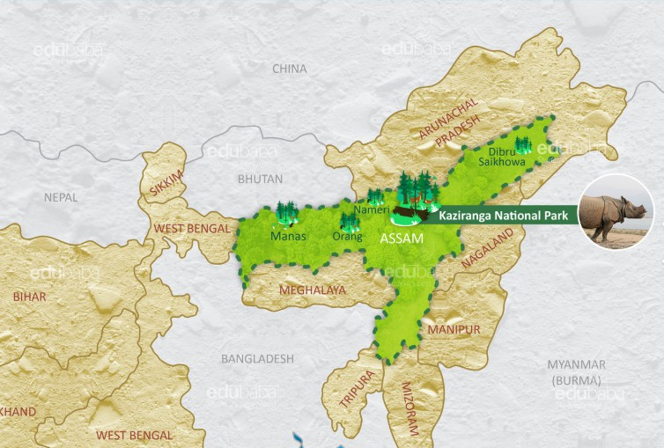
Fig. 1: Location Map of Kaziranga National Park, Assam
3.Biodiversity and Species Richness
Kaziranga possesses exceptionally rich biodiversity and supports a wide variety of wildlife. The park provides habitats for numerous species of mammals, birds, fish, plants and other organisms. Its diverse ecosystems also support different types of vegetation and medicinal plant species.
The Tiger Reserve contains a large variety of plant species, including trees, grasses, herbs and aquatic vegetation. Its vegetation consists of eastern wet alluvial grasslands, Assam alluvial plains, semi-evergreen forests, tropical moist mixed deciduous forests and wetlands.
Kaziranga is especially well known for its population of the Indian one-horned rhinoceros. It also provides important habitats for tigers, Asian elephants, wild water buffaloes, swamp deer, sambar, hog deer, gaur, sloth bears and many other wildlife species.
The wetlands of Kaziranga are also valuable habitats for resident and migratory birds. Its position along important bird migration routes makes the park an important region for bird conservation and biodiversity protection.

4.Major Flora and Fauna
Kaziranga’s vegetation mainly consists of tall grasses, wetland plants and scattered forest patches. Important plant species include Bombax ceiba, Albizia procera, Careya arborea and Lagerstroemia parviflora. Various grass species provide essential food and shelter for herbivorous animals.
The most well-known animal of Kaziranga is the Indian one-horned rhinoceros. The park is regarded as one of the world’s most important strongholds of this species and supports the largest population. Other important mammals include the tiger, Asian elephant, wild water buffalo, eastern swamp deer, sambar, hog deer, gaur, capped langur, hoolock gibbon and sloth bear.
The park also provides habitats for fish, reptiles, amphibians and a wide variety of birds. The endangered Ganges River dolphin has also been recorded in some of the park’s water bodies.

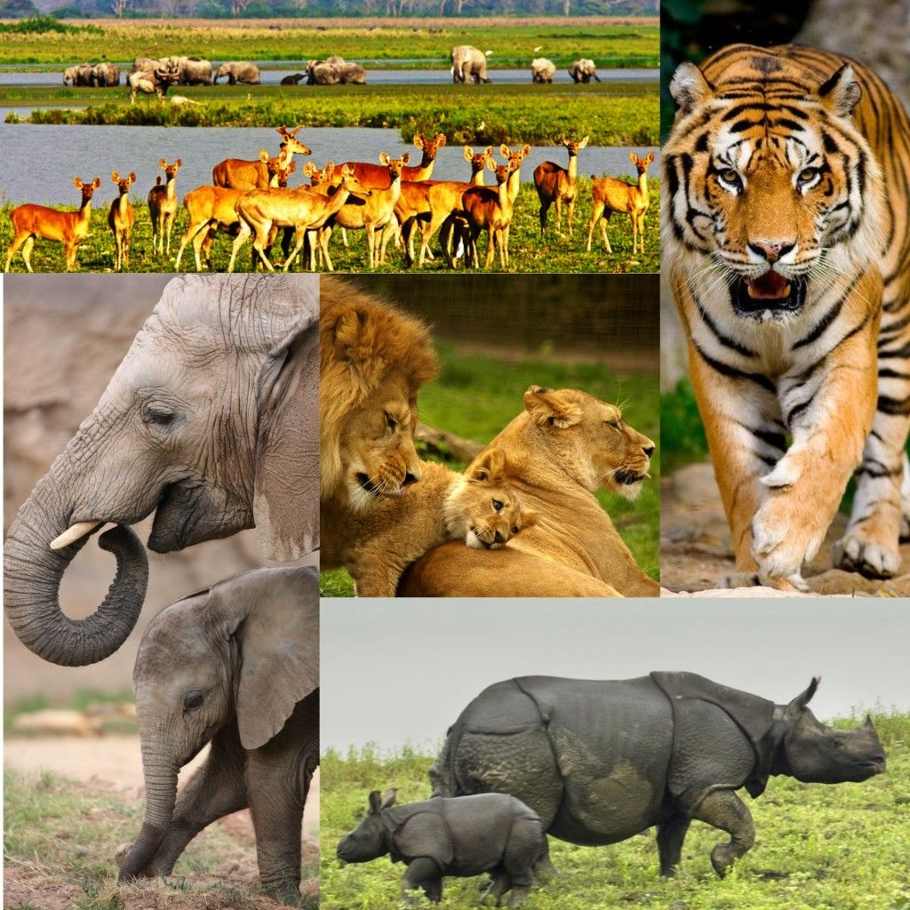
Fig. 2: Major Wildlife of Kaziranga
5.Importance of Kaziranga

Kaziranga is significant not only for its rich wildlife but also for its unique ecological systems and natural habitats. The seasonal flooding of the Brahmaputra, along with erosion and sediment deposition, regularly changes the landscape and creates new habitats.
The park has played a major role in protecting the Indian one-horned rhinoceros from the threat of extinction. Its conservation success shows how long-term protection, habitat management and effective anti-poaching measures can support the recovery of endangered species.
Kaziranga also provides shelter to several globally threatened species and serves as an important habitat for migratory birds. Its wetlands, grasslands and forests help maintain ecological balance throughout the Brahmaputra Valley.
The park is also important for tourism, education and scientific research. Wildlife tourism creates economic opportunities for local communities while increasing public awareness about biodiversity and wildlife conservation.

6.MajorThreats
Despite its conservation achievements, Kaziranga continues to face several environmental and human-related challenges.
Poaching
Illegal hunting, especially of rhinoceroses, has historically been a major threat to Kaziranga. Effective protection and monitoring have reduced this problem, but continuous anti-poaching efforts are still required.
Flooding
Annual flooding is a natural and essential part of Kaziranga’s ecosystem, but severe floods can force animals to move beyond the protected area. During these movements, wildlife may face road accidents, illegal hunting and conflicts with nearby communities.
Habitat Fragmentation
Human settlements, roads and development around the park can disturb wildlife movement. The busy National Highway 37 along the southern boundary can affect animal movement. Maintaining connectivity with the Karbi Anglong Hills is therefore important.
Human-Wildlife Conflict
During floods and seasonal movements, animals may enter nearby agricultural fields. This can cause crop damage and increase conflicts between wildlife and local communities.
Tourism and Development Pressure
Tourism provides economic benefits, but excessive tourism, traffic and unplanned development can disturb wildlife and increase pressure on the ecosystem. Other concerns include livestock grazing, invasive species, heavy highway traffic and riverbank erosion.

7.Conservation Efforts

Kaziranga has a long record of wildlife conservation and effective habitat management. The park receives strong legal protection under India’s wildlife and forest laws and is managed by the Assam Forest Department through a planned management system.

One of the major conservation achievements has been the successful recovery of the one-horned rhinoceros. Anti-poaching activities, trained protection staff, regular monitoring and strict law enforcement have helped maintain its population.

Kaziranga was declared a Tiger Reserve in 2007, providing additional protection to its tiger population and wider ecosystem. The park has also undergone several boundary extensions to strengthen habitat protection.

Conservation activities include habitat management, wildlife monitoring, protection of wetlands and grasslands, management of human-wildlife conflict and development of necessary infrastructure.

The Kaziranga Tiger Conservation Foundation supports long-term conservation funding and management activities aimed at protecting the park’s wildlife and natural habitats.

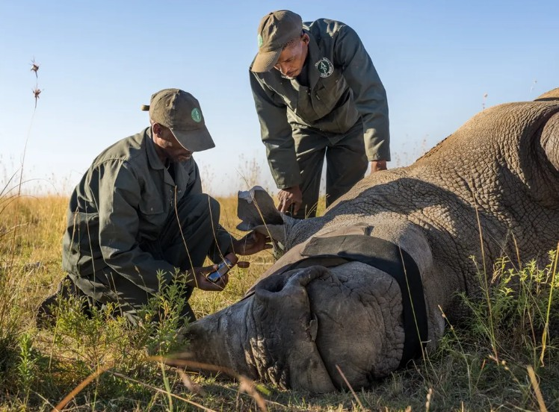
Fig. 3: Conservation Activities in Kaziranga
8.Role of Local Communities and Tourism
Local communities living near protected areas play a vital role in supporting biodiversity conservation. Human settlements and agricultural lands are present around Kaziranga, making cooperation between local residents and conservation authorities essential.
During floods, wildlife may move outside the park and come into contact with nearby communities. Effective measures to minimize crop damage, increase public awareness and provide proper support to affected residents can help reduce human-wildlife conflict.

Tourism can support wildlife conservation by creating employment and providing economic benefits to local communities. However, tourism activities should be properly controlled so that visitors do not disturb animals or negatively affect their natural habitats.
Responsible tourism should encourage visitors to follow park rules, maintain a safe distance from wildlife, keep the surroundings clean and contribute to local conservation efforts.

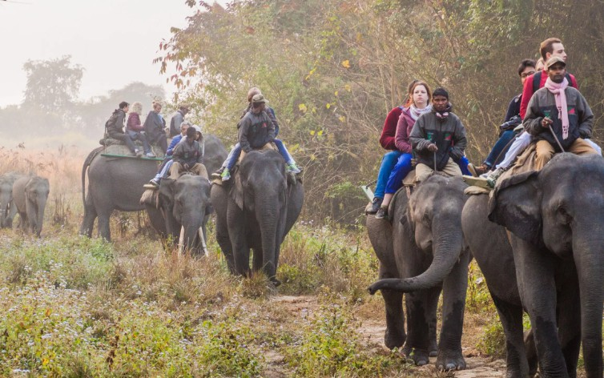
Fig4.Role Of local Communities.
9.Conservation Achievements
Kaziranga is widely regarded as an important example of successful wildlife conservation. The recovery of the Indian one-horned rhinoceros from a critically low population to more than 2,000 animals is one of its most notable achievements. This recovery highlights the effectiveness of long-term protection and conservation measures.
The park has also maintained healthy populations of tigers, elephants, wild water buffaloes and other threatened species. Its recognition as a UNESCO World Heritage Site and Tiger Reserve has further increased its importance for biodiversity conservation.
However, conservation is a continuous process. Ongoing protection, scientific monitoring, habitat connectivity and cooperation with nearby communities are essential to preserve these achievements and maintain the ecological balance of Kaziranga.

10.Conclusion
Kaziranga National Park is an important centre for biodiversity conservation in Assam, situated within the Brahmaputra floodplain near the Eastern Himalayan biodiversity hotspot. Its grasslands, wetlands and forests provide habitats for numerous species, including the Indian one-horned rhinoceros, tigers, elephants and wild water buffaloes.
Despite its conservation achievements, Kaziranga continues to face challenges such as poaching, flooding, habitat degradation, human-wildlife conflict and tourism pressure. Effective protection, habitat management and active participation of local communities are essential for its long-term conservation.

11.REFERENCES
- Assam Forest Department – Kaziranga National Park and Wildlife Conservation Information.
- UNESCO World Heritage Centre – Kaziranga National Park.
- National Tiger Conservation Authority (NTCA) – Kaziranga Tiger Reserve.
- Ministry of Environment, Forest and Climate Change, Government of India – Wildlife and Biodiversity Conservation.
- Wildlife Institute of India – Biodiversity and Wildlife Conservation Resources.

